**Controlling the Water Level in the column**

In order to control the Water level in the 1 meter column at a preset setpoint a PID block is used

The PID block is extracted from the Wago Library : Util 3.5.7.0 (system).

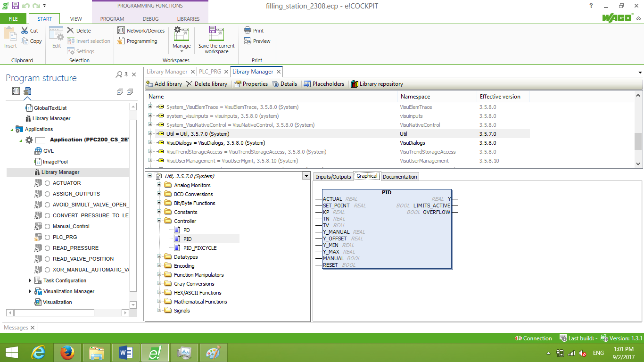

This PID is Parameterized as follows :

ACTUAL Value : vrController_PV = vrWaterlevel x 100

SET_POINT : vrController_Level_SP = Given from The Visualization by means of the Operator.

Y_MANUAL : vrValvePosition = the valve position input to AI = %IW1 vwRawValvePosition scalled 0-100%

KP : Controller Gain given from the visualization

TN : Controller Integral Component given from the visualization

TV : Controller Differential Component given from the visualization

Y-MIN : minimum controller output = 0%

Y-MAX : maximum controller output = 100%

MANUAL : value that changes controller into Manual mode= vbController_Manual_Mode given by Operator

from the visualization.

Y : Controller Output = vrController_Output , this output is continuous value from 0-100% in adequate

to control the water valve unless it is manipulates as will be shown later.

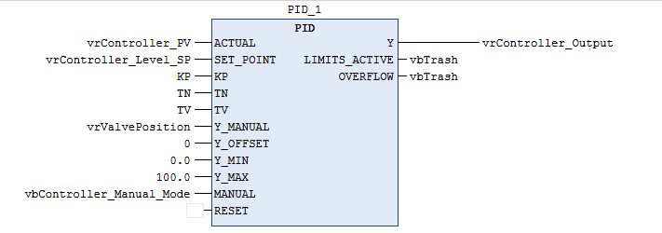

Manipulation of the Continuous controller Output :

Here in this section the PID controller output was manipulated in order to control the Water valve via two discrete

outputs : - %QW0.0 vbOpenSamsonValve

- %QW0.1 vbCloseSamsonValve

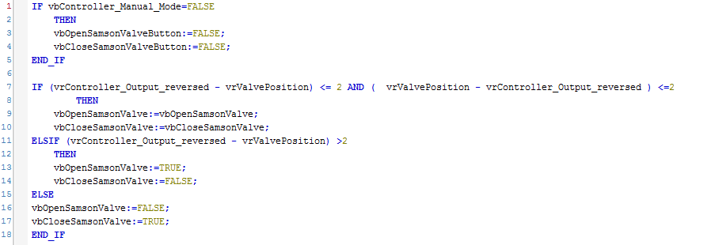

* Inverse the Output for reversible control ( when SP and PV then the Output , the reversed Output needed will hence the valve discrete output will close accordingly and vice-versa ).
* When the reversed output is more than the valve actual position by chosen dead-band (here 2%) the discrete output will open ( and vice-versa ).

Control in Manual Mode :

Using Reset_Set Flip Flops we can guarantee that in manual mode Operator can not by mistake Close the valve while the Open Command is set or vice-versa hence safety of the equipment is guaranteed.

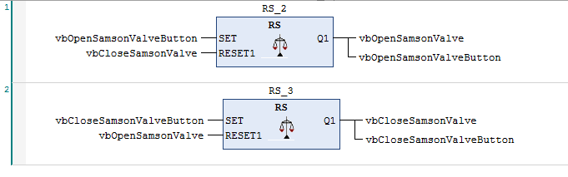

Tuning the PID parameters ( KP,TN and TV ) using Imperical Forms :

We used Ziegler Nichols method to Tune the PID parameters in the open loop and calculate the process reaction time in order to set the initial PID parameters (then these parameters can be altered during Operation by the Operator if needed)

